ENGR 1620
Introduction to Engineering
Section 13
Fall 2013

Assignment 13
Ability One Challenge

Team Clutch Crutch

Ahnaf Hassan (ath2fc)
Paul Kim (pdk2az)
Nik Padmanabhan (nep3uz)
Wisher Paudel (wp4ty)
Oscar Sandoval (oks2vd)
Scott Weiss (scw5sg)

On our honor, we have neither given nor received unauthorized assistance on this assignment. We have not collaborated with other students, either at the University or others, in the preparation of this report.
ABSTRACT
We wanted to build a design that would help people who are in a situation where they had to use crutches. We were inspired by people from our high schools, and the people around Grounds that seem to struggle with crutches. Therefore, our primary goal was to make a product that could hold frequently used items such as wallets, cell phones, pens, mp3 players, etc. for the person using the crutches. We also wanted to make sure that the product was light-weight so that it would not impede the handicapped person’s ability to use the crutches. The actual design has two pockets on the designated interior side of the crutch. One of the pockets is big enough to hold a cell phone, while the other is about the right size for a wallet. The product is made out of two types of fabric with the exterior being waterproof for ultimate protection. Finally, for firm support, five Velcro straps in total are used to hold the product onto the crutch, with four on the sides and one at the top.

PROBLEM
People with disabilities usually face a lot of trouble doing simple tasks that other people can do easily. Sometimes such disabilities make people less capable of being productive, which in turn can hinder their chances of being employed. Therefore, our job is to help people with disabilities so that they become employable. We chose to focus our efforts in helping people who have injured themselves and need to use crutches. These people not only have trouble with mobility, but also with carrying their belongings with them. With both hands at work operating the crutches, they cannot carry things except for in a backpack or in their pockets. This causes the person to have to get off of their crutches and take off their backpack or reach down into their pockets to obtain what they need. This can be time consuming and unnecessarily difficult if that person is getting out something that they frequently use. We want these frequently used objects to be easy to access without the usual hassle.

BACKGROUND
Currently there are devices that attach to crutches that are like backpacks. For example, Wal-Mart sells a product called the Crutch Caddy that fastens right below or above the hand-grip. They carry everything from fruit to books to water bottles. This design would allow more personalization of storage. The Crutch Caddy consists of one smaller compartment, which faces out from the crutch. Within the single compartment, multiple other compartments that can hold certain things. Also, the main pocket of the Crutch Caddy is sealed by a zipper. Another example is the Versa Crutch Pack. This is very similar to the Crutch Caddy; however, this device is mainly attached below the hand grip. It also has zippers, and faces outward.

RATIONALE
Too often have physical disabilities been an impairment for its victims not just in the workplace, but in their everyday life as well. For people who have injured one of their feet, crutches are the immediate solution for temporary affliction. Yet crutches have several fatal flaws accompanying them, including how easily they exhaust their users and require all of the body’s resources to function. Little wiggle room is allotted while utilizing crutches, so our product, the Crutch Clutch, accommodates what crutch users are able to perform. By placing our Crutch Clutch in the empty area between the armpit rest and the hand grip of a typical crutch, it does not disturb the motion of crutch use while simultaneously utilizing space that is not being put to use. By having all the pockets of the Crutch Clutch facing the exterior side of the crutch, its user will only have to raise their hand from the grip to access their essentials, such as phones, wallets, and keys. Previous methods of storing essentials, such as pants pockets and backpacks, are difficult to access while the user is on crutches. With the Crutch Clutch, all of the struggle associated with accessing the fundamental tools of life will be absolved. The Crutch Clutch is also lightweight, which does not require additional strength from crutch users. Additional features of the Crutch Clutch include various designs and colors for appealing to a wide range of audiences and waterproof capabilities.

DEVELOPMENT
We looked at already existing crutch “bags” and tried to find problems with each of them. For example, designs like the Crutch Caddie and other backpack-like carrying devices seem bulky. They also look like they might be heavy. Because of this we decided that the carrying device should be less bulky. Also, we noticed that some of the backpack-like designs were placed lower on the crutch, which would cause the user to have to stop using the crutches and bend down to obtain what they needed. Because of this, we chose to make the carrying-design attach closer to the top of the crutch for easier accessibility.
Many of the designs that are currently available have zippers. This does not allow for very quick accessibility. Our design utilizes multiple kinds of Velcro for different parts of the design. Industrial strength Velcro is used to attach the design onto the crutch, and regular strength Velcro is used to keep pocket flaps down. We initially wanted to connect the design only to the side bars of the crutch. Later, we realized that we needed a strap to keep the design from sliding down the crutch. Our design now has a strap that goes around the top of the crutch to prevent sliding. To use the most space possible, we designed the Crutch Clutch to go down the inside of the crutch. For crutches used by smaller people, the Crutch Clutch extends over the hand grip while not impeding the usage of the crutch.
Our team brainstormed about simple tasks that people with crutches would have a harder time performing. For example, accessing things that they use frequently, like a wallet, cell phone, or pens and pencils. We then decided that our design should be used to carry the things that people with crutches use most frequently. Since our design is made to carry these things, we were able to make the design less bulky and less heavy.

FINAL DESIGN
(How is design unique, superior to others in market, and easily adaptable?)(We could not finish this section because we do not have our final design yet.)
Our final design is a caddy-like compartment that is attached to a crutch by Velcro straps.
This design is unique in that it accounts for smaller items such as a cell phone, mp3 player, other handheld devices, wallet, or even pencils and pens. It is superior in that our device is designed specifically for these end uses in mind, giving users a more effective product.

COST ANALYSIS
Judging by costs of constructing a prototype, we estimate that the final cost will be under $20.00. We estimated that the amount of PLU fabric that we used was $7.00, the polyester fabric was $5.00, the industrial strength Velcro was $4.00, and the Gorilla Glue was $1.00.

TESTING PROCEDURE AND RESULT
(these tests have not been performed yet)
Once a prototype is completed, it will need to be tested to make sure that all of our intended designs work the way that they are supposed to. Multiple people will be testing the Crutch Clutch to give different opinions. Each tester will use the Crutch Clutch multiple times, each with a different amount of items inside. For each trial, the tester will comment on stability, usefulness, and comfort. Since the Crutch Clutch will be tested many times, its durability will also be commented on.
After all the comments are in, our group will be able to decide on what changes will need to be made for the next prototype. For example, if comfort decreases as the amount of items in the Crutch Clutch increases, our group will have to change the design of the pockets. Also, comments relating to the usefulness of the Crutch Clutch will determine the design of our next prototype. For example, if the testers comment that the flap on our pockets makes reaching items harder, they will need to be fixed.
The final test that will be conducted is a test for whether the Crutch Clutch is waterproof or not. Ideally, The Crutch Clutch will be placed out in the rain to determine if it successfully keeps water out, but we could instead use a shower. If the Crutch Clutch does not successfully keep water out, our design will be changed accordingly.

COMMUNITY IMPACT
The use of this device would help disabled persons throughout the community, empowering them by allowing them more freedom and flexibility regardless of the physical limitations they may face. For example, Mona Hajjar, Nik’s mom and a previous crutch user, commented on some of the problems she faced. “When going to meetings, I had to either get someone to carry some of my things, or I wouldn’t take it at all,” Hajjar said. The Crutch Clutch will not only help crutch-users carry small items, but it will also allow people more freedom in their schedules. People would not have to continually plan everyday trips ahead of time, because other people would not help them carry important items. Overall, the Crutch Clutch will empower crutch-users, facilitating everyday life with regards to carrying items and simply planning their day.

CONCLUSION
After our design has been tested and our group has made the best design possible, we will be able to make conclusions about the design as a whole. We will be able to decide whether our Crutch Clutch will successfully facilitate the lives of crutch-users. If so, we can also conclude whether our design is cost efficient. Will it be worth making additional Crutch Clutches, or will it be too expensive to realistically distribute. Also, we will be able to conclude whether our design improves on similar ideas, such as the Crutch Caddy. Our team’s goal for our design to improve the lives of crutch-users, be cheap, and be something that crutch users find useful to purchase.

TEAM INFORMATION, MEMBERS AND THEIR ROLES
Team Name: Team Clutch Crutch

Scott Weiss
Project Manager- He organizes group meetings, makes sure people are doing their jobs, and aids in the building of the design.

Nik Padmanabhan
Architect- He is the primary builder, is in charge of materials and their use in construction, and uses measurements to construct the design.

Oscar Sandoval
Record Keeper – He archives important information such as crutch measurements, group accomplishments, and materials utilized in the construction of the Crutch Clutch.

Paul Kim
Communicator – He makes sure team is cooperating and working together to achieve common goal.

Wisher Paudel
Financial Manager – He oversees the financial aspects of the project and keeps track of cost of materials, while also helping out in other areas if necessary.

Ahnaf Hassan
Researcher- He researches past designs and finds the sources of the materials that we need.

MENTORS/PARTNERS/ADVISORS
Student Health Services helped us by generously providing our group with free crutches.

Mona Hajjar provided insight into her life when she broke her leg and was forced to use crutches.

TIMELINE

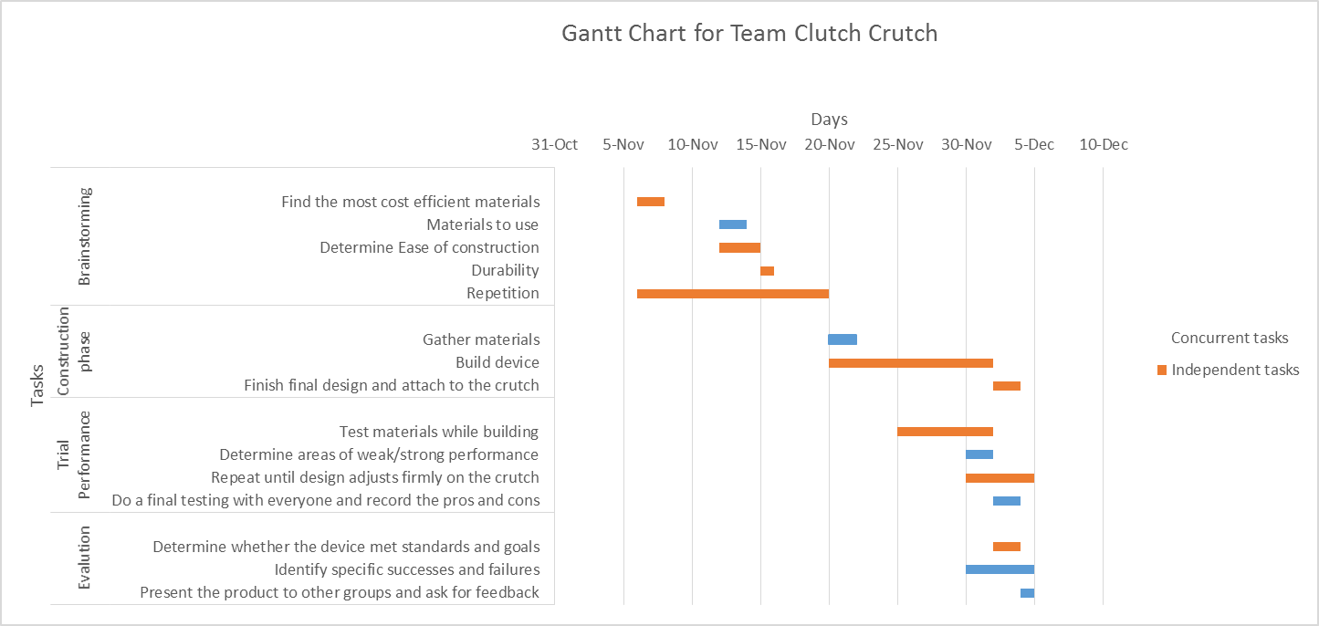

REFERENCES AND GUIDELINES
Care Medical Source (2012). ADAPATABLE DESIGNS Versa Crutch Pack. Retrieved from
http://www.caremedicalsource.com/Brand/Adaptable-Designs/Shop/Walking-Aids/Cane-Crutch-Accessories/Crutch-Packs/ADAPTABLE-DESIGNS-Versa-Crutch-Pack

Hajjar, M. (2013, November 23). Telephone Interview.

Juvo (2013). Crutch Caddy. Retrieved from http://www.juvoproducts.com/crutch-caddy-pages- 50.php

(more sources to come)

